Statement of Work

This document will be sign by all group members of Whatever Inc. As proof that everyone was able ti deliver their roles on time and also making a effort in helping the group on what was needed

Taha Ababou: Interface Lead/Project Lead

Timeline

User interface Reasearch/Design

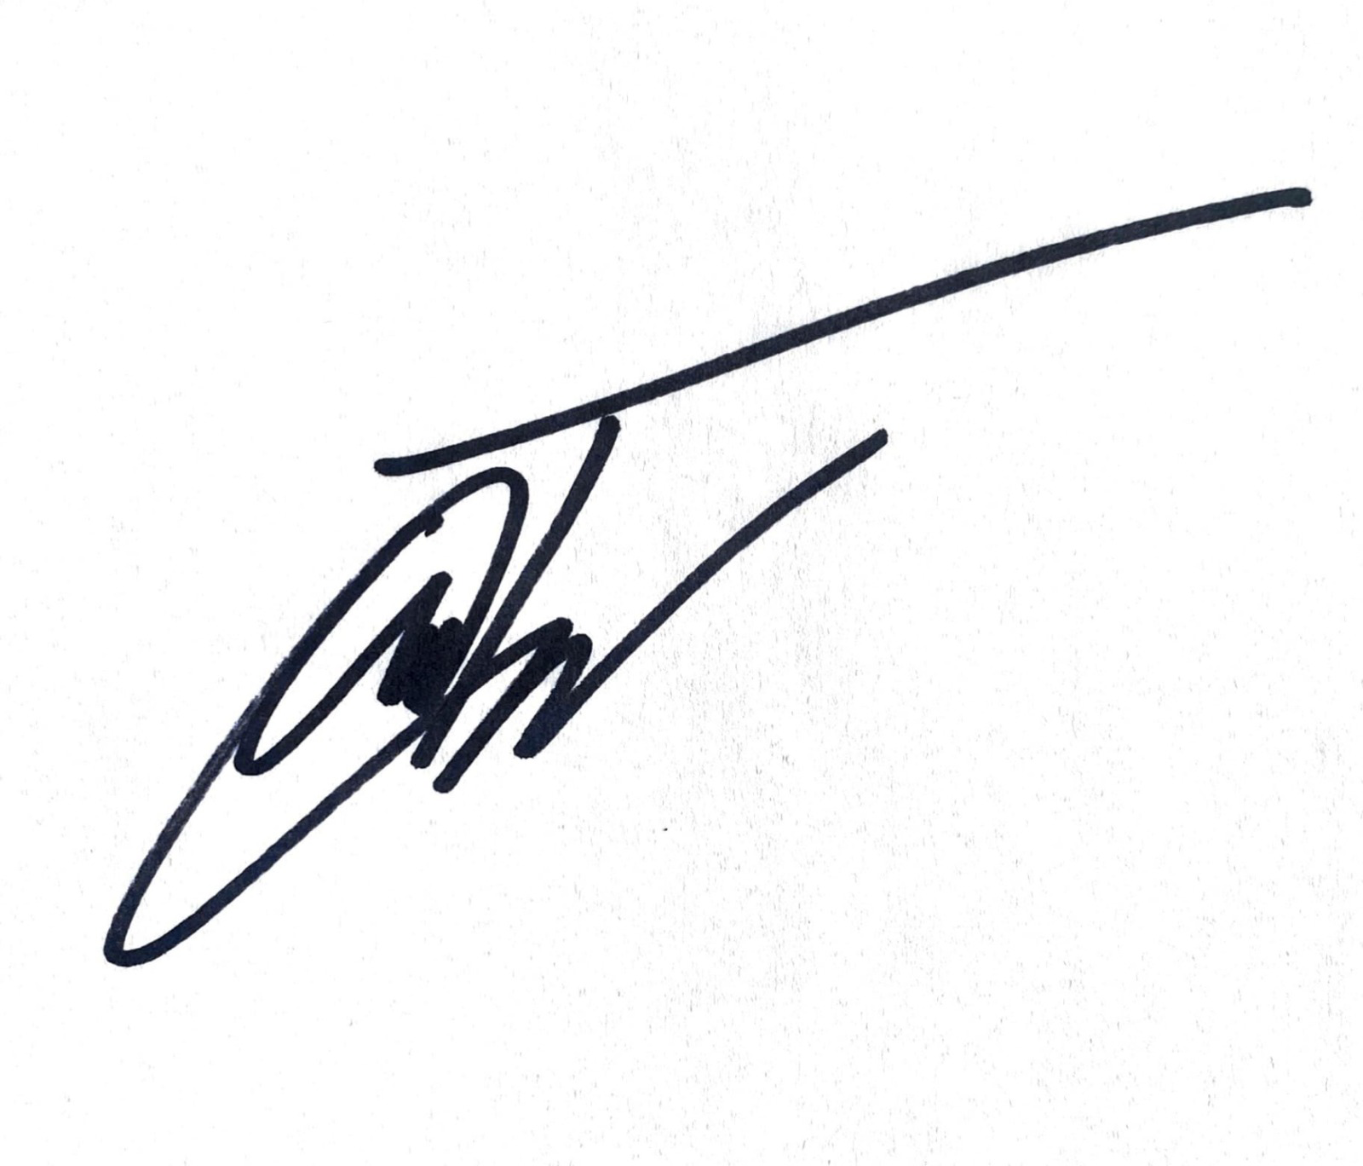Sign:

Joel Akerman: Documentation Lead

Version Control System that Maintains Code

Packing all code

Documentation

Video

Sign:

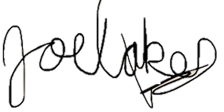

Manuel: Specification Lead/Project Lead

Main Program

API Reasearch/Test

Program to call API

Test Enhance Image

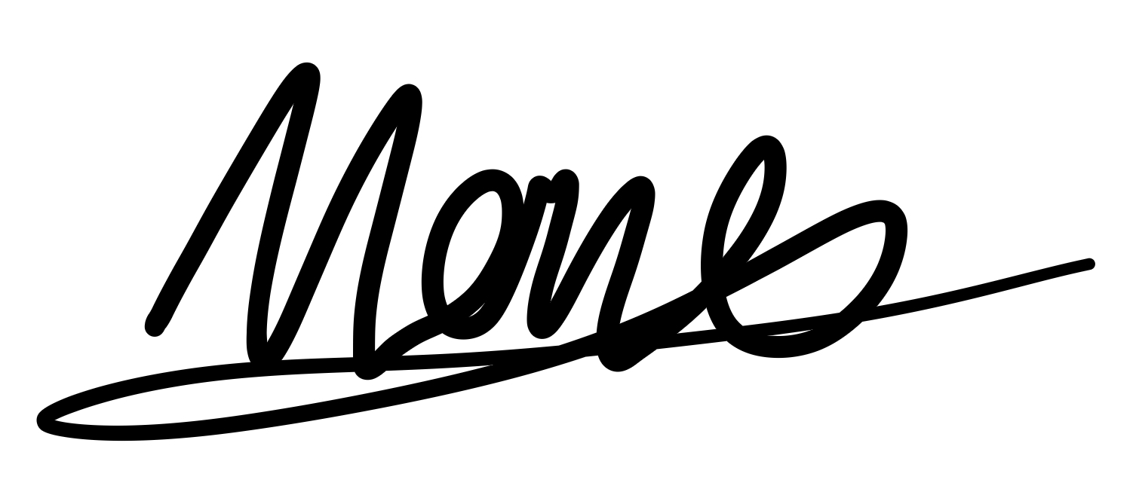Sign:

Axel: Technical Lead

Very similar to this, without the tts thing and image processing

API interfacing with the app backend

Coordinate the API server and app backend to work together

Try out the best combination of parameters for calling the REST API

Sign:

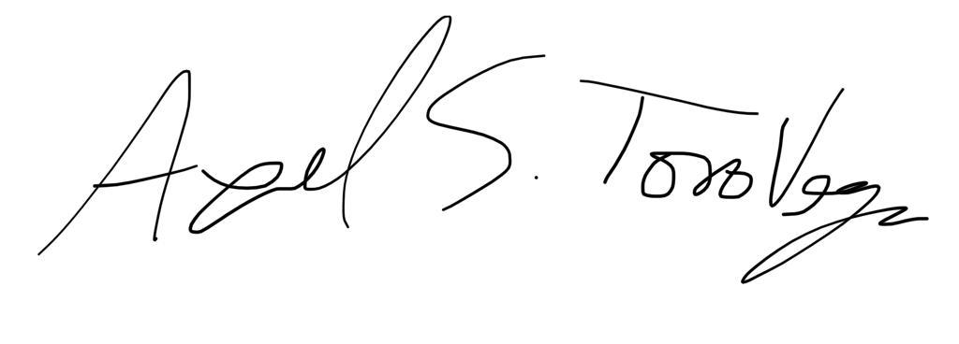

Jakub: Technical Lead

Android Back-End Devolopment/Reasearch

Camera frame capture functionality

Text-to-Speach

API interface with back-end

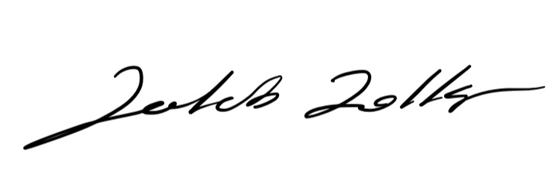Sign:

